|  |  |  |  |  |  |  |  |  |  |  |  |
| --- | --- | --- | --- | --- | --- | --- | --- | --- | --- | --- | --- |
| **Project Name: demo.opencart.com** | | | | | | | | | | | |
|  | | | | | | | | | | | |
| Bug ID | | 004 | | | | | Reporter | | | Kirill Brezhniev | |
| Test-case ID | |  | | | | | Position Reporter | | |  | |
| Description | | Not displaying number of products in subcategory of “Desktops” on in the product navigation ribbon | | | | | Submit Date | | | 20.11.20 | |
| URL | | https://demo.opencart.com/index.php? | | | | | Release Version | | | OPENCART.CMS 2.1.0.2 | |
| Priority | | high | | | | | Environment | | | Opera 72.0.3815.320 | |
| Severity | | moderate | | | | | Assign to | | |  | |
|  | | | | | | | | | | | |
| Pre-conditions | | | Main page is opened | | | | | | | | |
| Dependencies | | |  | | | | | | | | |
| Steps to reproduce: | | | | | | | | | | | |
| N | Action | | | Inputs | Expected Output | Actual Output | | Screen  shots | Comments | |
| 1 | Hover a cursor over “Desktops” category | | |  | Correct number of PC is displayed in subcategory | Number of PC in subcategory is 0 | | Bug4 |  | |

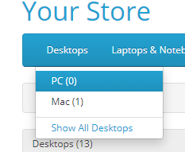bug4